Typical household circuits
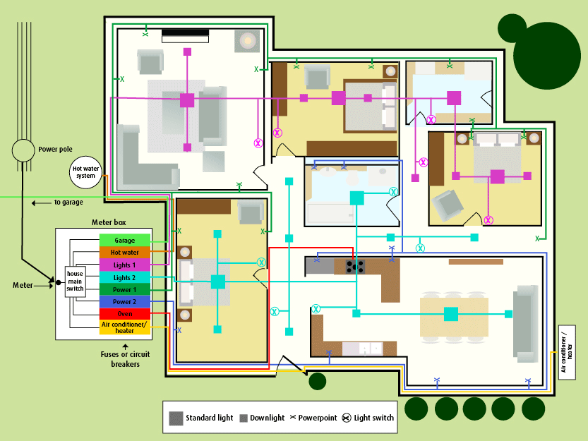
Diagram of typical household circuits (ActewAGL) http://www.actewagl.com.au/ Used with permission.
A typical household is connected to powerlines that run to a power station. A power station is an industrial facility that generates electricity. However, not all houses are connected to power stations.
It is important that circuits do not get overloaded. That is why you will notice that appliances that use a large amount of electricity over a short period of time usually have their own circuit, e.g. the oven and hot water system.

